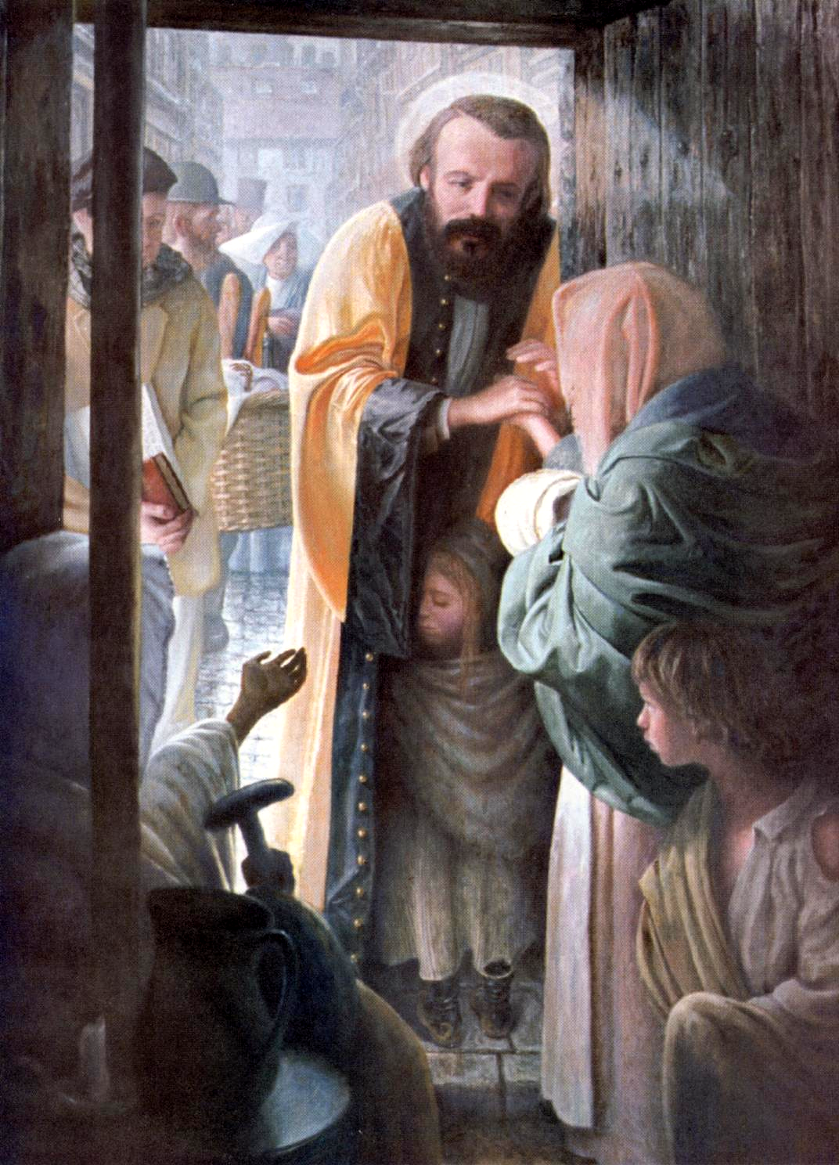
A MEDITATION ON THE ICON
OF
FREDERIC OZANAM
ON A HOME VISIT

Challenged to “Go to the Poor” and encouraged by Emmanuel Bailly, their leader and mentor, Frederic and his companions went to Sr Rosalie Rendu, a Daughter of Charity living in the desolate Mouffetard district of Paris.

Sr Rosalie gently formed the hearts of Frederic, and his friends, into the Vincentian spirit by sending them to visit the homes of those living in the Mouffetard district. Thus, in the Providence of God, these young men began the Society of St. Vincent De Paul.

And so, let us meditate on the icon “The Home Visit.” It is important to know that we don’t pray at an icon, but through an icon. Icons show a way, they guide our eyes on a journey around the image and lead us into contemplation. And so looking at the icon, first we see:

- In the doorway we see Frederic, dressed in his academic robes, making a home visit in the Mouffetard district, on a cold and damp winter day. Frederic would not have worn his professorial robes to a home visit, but the icon captures the truth that he was a teacher and a mentor.

- Inside the dark, dirt floor home we see a:
    - Mother, holding a baby, who offers her hand in welcome to Frederic and he gently grasps her hand in compassion.
    - Looking carefully in front of the mother, we see a small little girl hugging Frederic in friendship, because she recognizes and trusts him. Frederic has been there many times before.
    - Our eyes move to the left where we see a Grandmother, holding her cane in one hand, and reaching out in gratitude.
    - In the corner beside the grandmother, we see a small stove with an unlit candle sitting on it, indicating that there is no fire in the stove. The grandmother and the mother are both wearing shawls telling us that their home is very cold.
- As a teacher at the Sorbonne Frederic would address the justice issues of the working poor because, by experience, he knew their suffering. Frederic encouraged his students to serve those who were poor, and he would always tell them that:

“The knowledge of social well-being and reform is to be learned not from books nor from the public platform, but in climbing the stairs to the poor man’s garret, sitting by his bedside, feeling the same cold that pierces him.”

Looking further at the icon, we see that Frederic brings two students with him:

  - The first student is holding a book and a tablet. He has come to tutor the shy and cautious young boy that he sees standing behind his mother.
  - As we look we can see that the young boy is gazing directly at the student, and we can feel the expectation and hope that is in his heart.
  - The other student is carrying a basket of bread and food to give to the family. We see him looking out, seeing so many other families who are hungry and suffering. He is wishing he had more to give.
  - Together these 2 students capture Frederic’s call for justice and charity…the same call we hear today to serve those living in poverty through systemic change

- Knowing how Frederic stood on the shoulders of giants who had loved life into him and taught him how to live his Vincentian Vocation, looking deeper into the center background of the icon, we see:
    - Sr. Rosalie Rendu in the white wings of the Daughter of Charity. As she mentored Frederic, he is now mentoring others to love and serve with a Vincentian heart.
    - Behind Rosalie, we can see the top hat of Emmanuel Bailly, who also guided and mentored Frederic and the founding members to “Go to the Poor”.

Take a moment to contemplate the Providence of God in your own life:
    - When did you hear the challenge to “Go to the Poor?
    - How did you discover that you had a Vincentian Heart?
    - Who have been your teachers and mentors?
    - Who are you inviting and mentoring?
    - What does justice and charity in systemic change call you to do?

(By Sister Kieran Kneaves, DC)

